**ISEC 520 – Ethical Obligations in Information Security**

**Lab 4: Performing a Denial of Service Attack from the WAN**

The requirements for this lab are to capture the screenshot of the below steps from given sections and submit in the word document. Flag screenshot #1 is shown as an example.

**Part 1**

**challenge #1**

* **Flag screenshot #1**



**challenge #2**

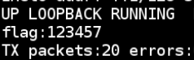

**challenge #3**

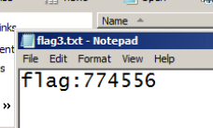

**challenge #4**

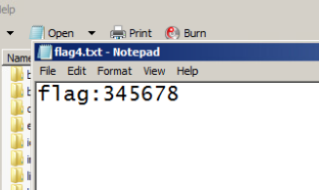

**challenge #5**

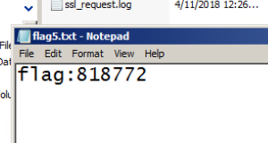

**challenge #6**

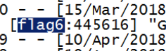

**PART 2**

When we look at the topography of the network, we can see that we have one local network and then we have an external host. So we are dealing with two public ip addresses. We log into the linux machine in the local network and check our network parameters using the ifconfig bash command. Then we use the pipelining feature of the bash commands to send the information of inconfig command into ip1.txt. Then we use the cat bash command to read text files. We remove our ipv4 using ifconfig command.

We log into the host in the other public ip address now and launch LOIC. And if we look at the network topography, the ip we use for the attack is the public ip address of the local network. The tcp listener counted 4843 packets.

Now we start the UDP listener instead of the TCP listener. And this time the listener counted 106 packets.

Now we start the HTTP listener. And the listener counted 99 packets.

We start the HTTP listener again. And the listener counted 354 packets.

Xampp is a program that can be used to host a local server called localhost. All the requests we did were requests to this server hosted by xampp. When we take a look at the log file of apache that gets installed with xampp, we were able to see the requests we sent and the message they contained.